Assignment – 8
Backward Chaining Algorithm

Problem Statement:
The Backward Chaining Algorithm is a goal-driven inference method used in rule-based systems and expert systems. It starts with a specific goal and works backward to determine if the facts necessary to achieve that goal are available. If the required facts are not present, it tries to find out which rules can derive the needed facts until either the goal is achieved or it becomes clear that the goal cannot be satisfied.

Software used:
- Python 3.x
- Google Colab

Libraries and packages used:
- NumPy: For data handling.
- Pandas: For managing rules and facts in a structured manner.

Theory:
The Backward Chaining Algorithm works by attempting to prove a goal by breaking it down into sub-goals. It checks if the goals can be satisfied with known facts and recursively resolves the sub-goals. The main components of the algorithm are:
- Goals: The desired conclusions to be achieved.
- Facts: The available data that can be used to infer conclusions.
- Rules: Conditional statements that define how facts can be used to achieve goals, typically in the form of "IF conclusion THEN condition."
Working Mechanism:
- Start with the goal to be proven.
- For each goal, check if it is a known fact.
- If it is not a known fact, find rules that can lead to that goal and treat the conclusions of these rules as new sub-goals.
- Repeat the process until all sub-goals are either proven or shown to be unachievable.

Methodology:
- Define the Knowledge Base: Create a set of initial facts and rules that represent the domain of interest.
- Implement the Backward Chaining Algorithm:
- Initialize the goal to be proven.
- For each goal, check if it is already in the set of known facts.
- If not, find relevant rules that can infer this goal and recursively check the sub-goals until the initial facts are reached.
- Repeat until no new facts can be derived.
- Goal Checking: Return true if the goal is achieved; otherwise, return false if the goal cannot be satisfied.

Advantages:
- Efficiency: It is often more efficient than forward chaining for problems where specific goals are sought, as it only explores relevant paths in the rule set.
- Focused Search: It works backward from the goal, which can lead to faster conclusions by reducing unnecessary rule evaluations.
- Dynamic: It allows for dynamic querying of the knowledge base, responding to specific goals rather than generating all possible conclusions.

Limitations:
- Limited Scope: It may not find all possible solutions since it focuses solely on achieving the specified goal.
- Complexity: Implementing backward chaining can become complex, especially with many interdependent rules and goals.
- Dependency Issues: If the required facts to achieve the goal are missing, the algorithm will fail to derive the conclusion.

Applications with example:
- Expert Systems: Used in expert systems for medical diagnosis, where the goal is to determine a disease based on symptoms.
- Rule-Based Systems: Useful in production rule systems for troubleshooting or making decisions based on specific conditions.
Example: Consider a simple medical diagnosis system with the following facts and rules:
Facts:
- The patient has a fever.
- The patient has a headache.
Rules:
- If the patient has a fever and a headache, then the diagnosis is "Flu."
- If the patient has a cough, then the diagnosis is "Cold."
To prove the goal "Flu," the algorithm checks if the relevant conditions (fever and headache) are satisfied.

Working / Algorithm:
- Define Facts and Rules: Create a list of initial facts and rules.
- Implement the Backward Chaining Function: Create a function to apply the backward chaining algorithm.
- Execute the Algorithm: In the main function, invoke the backward chaining process to prove a specific goal.

Diagram:
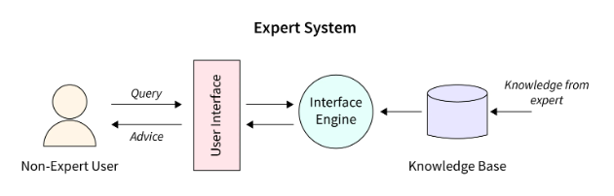
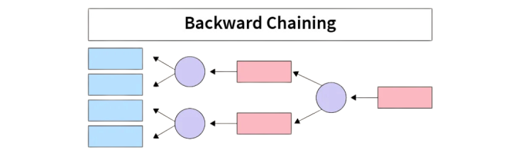

Conclusion:
The Backward Chaining Algorithm is a powerful reasoning method in artificial intelligence, enabling systems to derive conclusions based on specific goals and available knowledge. By focusing on proving goals through recursive rule application, it efficiently narrows the search space, making it well-suited for expert systems and rule-based reasoning applications. This assignment highlights the importance of logical inference in AI and provides a foundation for understanding more complex reasoning strategies.

